Laboratory assignment №2
Topic: Development with ASP.NET MVC. Project configuration. Displaying data from DB on web-pages.
Goal: Get acquainted with the MVC architecture, acquire skills in creating the main components of the MVC architecture, learn how to configure database connections and execute data reading queries, and acquire skills in working with views.

Workflow:

Task 1. Project creation and configuration
Create a project based on the MVC architecture following the instructions below.

First of all, familiarize yourself with the topic of your project, which you will develop during the next laboratory assignments. The topic of the project is determined by your number on the group list. If you do not like the topic, you can choose your own, but you need to agree on a topic with the teacher. The variants are given in Table 1.1.
Table 1.1. Topics of individual projects
Number on group list | Topic | Short descriptions of functionalities
1 | Event Ticket Booking Website | Users can search for events, book tickets, and manage bookings, while administrators can add and modify events.
2 | Course Management System | Students can register, view, and drop courses, while instructors (administrators) manage courses.
3 | Job Portal | Employers can post job listings, and candidates can apply for jobs and manage their applications.
4 | Hospital Appointment System | Patients can schedule doctor appointments, view schedules, and receive reminders. Doctors and administrators manage doctor availability.
5 | Survey Portal | Users can register and participate in surveys, while administrators create and analyze survey results.
6 | Hotel Room Booking Website | Users can browse available rooms, make reservations, and check booking history, while administrators manage rooms and pricing.
7 | Vehicle Rental System | Users can browse available vehicles (cars, scooters, bicycles, etc.), make reservations, and return vehicles, while administrators manage the fleet.
8 | Movie Ticket Booking Website | Users can browse currently showing movies, book seats, and manage bookings, while administrators manage movie schedules, seat availability, and cinema halls access.
9 | Volunteer and Charity Event Management System | Users can browse and register for charity or volunteer events, make donations to active fundraisers, while administrators manage events and collections.
10 | News Portal | Users can browse news, add articles to favorites, leave comments, while administrators manage news content and moderate comments.

Create a project by executing the following commands. The names of the directories and files should be appropriate to the topic of your project. The following commands and code are for the online sports goods store SportsStore that will be used as an example for explanations.

dotnet new globaljson --sdk-version 8.0 --output SportsSln/SportsStore

This command will create a global.json file in the SportsSln/SportsStore directory. This file is needed to avoid issues when working on the project collaboratively in a team. It ensures that all developers working on the project are using the same version of the .NET SDK, preventing compatibility issues.

The next one is:

dotnet new web --no-https --output SportsSln/SportsStore --framework net8.0

This command creates a new project of type ASP.NET Core minimal web API, the --no-https option disables the HTTPS setting, which is convenient for local development. The --output option with the value SportsSln/SportsStore indicates that the project should be created in the SportsSln/SportsStore directory. The --framework option with the value net8.0 indicates that the project should use .NET8.

The next one is:

dotnet new sln -o SportsSln

This command creates a solution file (.sln) in the SportsSln directory.

The next one is:

dotnet sln SportsSln add SportsSln/SportsStore

This command adds the SportsStore project to the SportsSln solution file.

After execution of the mentioned commands the project structure should look like on the Fig. 1.1.
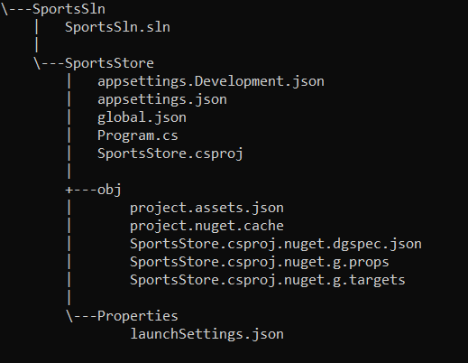
Fig. 1.1. Project structure

After that, open the created solution file in Visual Studio.
Alternatively, you can create a project and solution using the Visual Studio GUI with the same settings as in the above commands. The process of creating a project using the GUI is shown in Figures 1.2.-1.4.
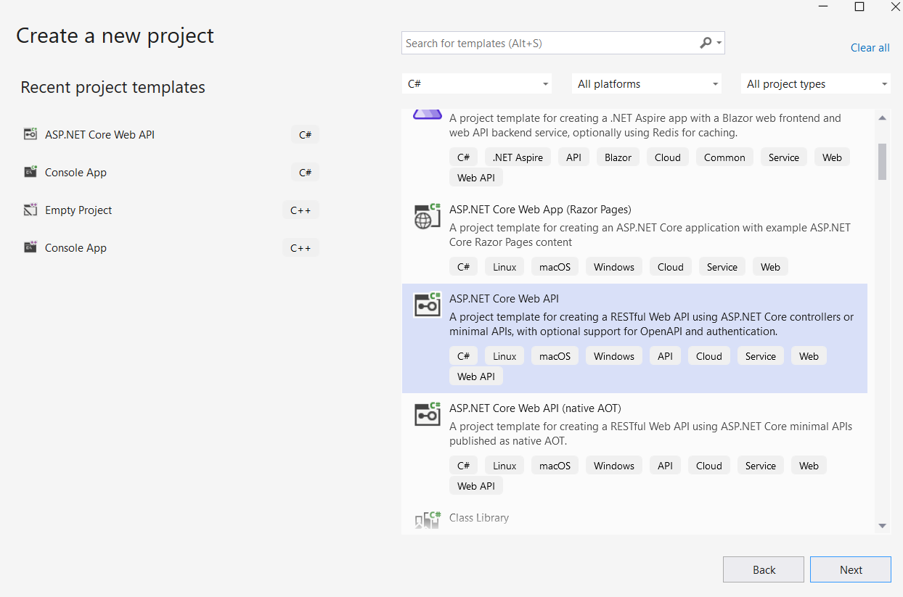
Fig. 1.2. Choosing the project template
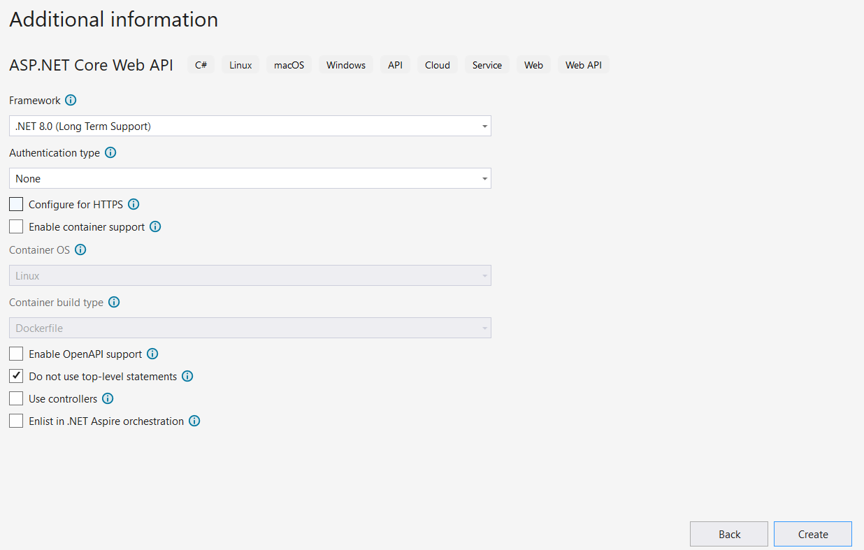
Fig. 1.3. Additional information
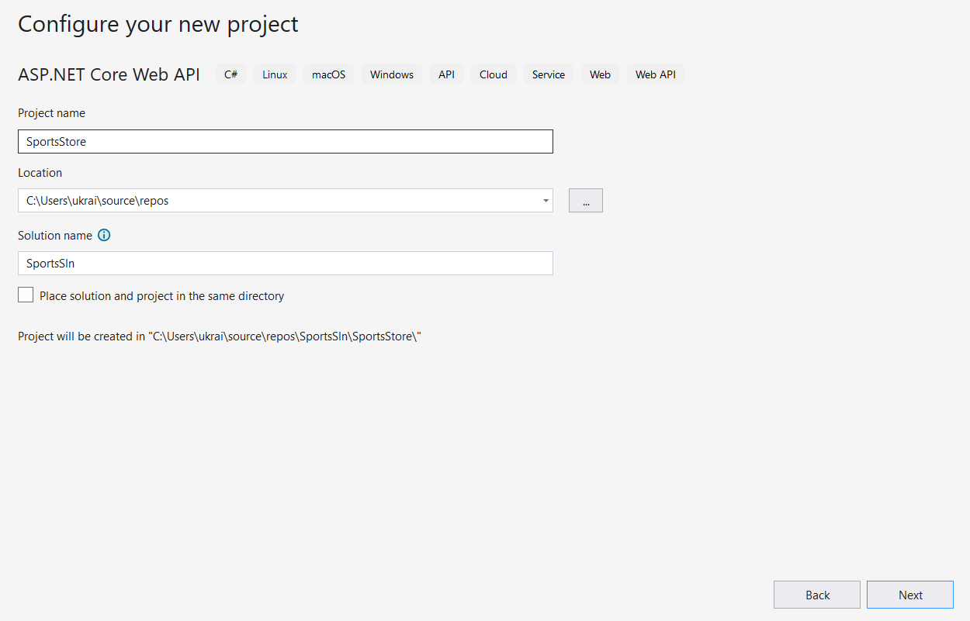
Fig. 1.4. Solution and project name

To configure the HTTP port that ASP.NET Core will use to listen for HTTP requests,
make the changes shown in listing below to the launchSettings.json file in the
SportsStore/Properties folder.

{
"iisSettings": {
"windowsAuthentication": false,
"anonymousAuthentication": true,
"iisExpress": {
"applicationUrl": "http://localhost:5000",
"sslPort": 0
}
},
"profiles": {
"SportsStore": {
"commandName": "Project",
"dotnetRunMessages": true,
"launchBrowser": true,
"applicationUrl": "http://localhost:5000",
"environmentVariables": {
"ASPNETCORE_ENVIRONMENT": "Development"
}
},
"IIS Express": {
"commandName": "IISExpress",
"launchBrowser": true,
"environmentVariables": {
"ASPNETCORE_ENVIRONMENT": "Development"
}
}
}
}

The next step is to create folders, mentioned in table 1.2, that will contain the application’s components.

Таблиця 1.2.
Name | Description
Models | This folder will contain the data model and the classes that provide  access to the data in the application’s database.
Controllers | This folder will contain the controller classes that handle HTTP requests.
Views | This folder will contain all the Razor files, grouped into separate subfolders
Views/Home | This folder will contain Razor files that are specific to the Home controller, which I create in the “Creating the Controller and View” section.
Views/Shared | This folder will contain Razor files that are common to all controllers.
The next step is to configure the basic application features
The Program.cs file is used to configure the ASP.NET Core application. Apply the changes shown in listing below to the Program.cs file in your project.
var builder = WebApplication.CreateBuilder(args);

builder.Services.AddControllersWithViews();

var app = builder.Build();

app.UseStaticFiles();

app.MapDefaultControllerRoute();

app.Run();
Here are some details about the previous code:
- The builder.Services property is used to set up objects, known as services, that can be used throughout the application and that are accessed through a feature called dependency injection.
- The AddControllersWithViewsmethod sets up the shared objects required by applications using the MVC Framework and the Razor view engine.
- The UseStaticFiles method enables support for serving static content from the wwwroot folder and will be created later.
- The endpoint routing feature is added to the request pipeline automatically, and the MapDefaultControllerRoute registers the MVC Framework as a source of endpoints using a default convention for mapping requests to classes and methods.
Let's move on to the Razor Engine setup. The Razor view engine is responsible for processing view files, which have the .cshtml extension, to generate HTML responses. Some initial preparation is required to configure Razor to make it easier to create views for the application. Add a Razor View Imports file named _ViewImports.cshtml in the Views folder with the content shown in the following listing:
@using SportsStore.Models
@addTagHelper *, Microsoft.AspNetCore.Mvc.TagHelpers
Important: Visual Studio will show an error on the line “@using ProjectName.Models”, but this will be fixed in the next steps.
Add a Razor View Start file named _ViewStart.cshtml to the SportsStore/Viewsfolder with the content:
@{
Layout = "_Layout";
}
The Razor View Start file tells Razor to use a layout file in the HTML that it generates, reducing the amount of duplication in views. To create the view, add a Razor layout named _Layout.cshtml to the Views/Shared folder, with the content shown in listing below:
<!DOCTYPE html>
<html>
<head>
<meta name="viewport" content="width=device-width" />
<title>SportsStore</title>
</head>
<body>
<div>
@RenderBody()
</div>
</body>
</html>
Add a class file named HomeController.cs in the /Controllers folder and use it to define the class shown in the next listing. This is a minimal controller that contains just enough functionality to produce a response.
using Microsoft.AspNetCore.Mvc;

namespace SportsStore.Controllers
{
public class HomeController : Controller
{
public IActionResult Index() => View();
}
}
The Index action method doesn’t do anything useful yet and just returns the result of calling the View method, which is inherited from the Controller base class. This result tells ASP.NET Core to render the default view associated with the action method.
To create the view, add a Razor View file named Index.cshtml to the Views/Home folder with the content shown in the following listing:
<h4>Welcome to SportsStore</h4>
Next, let's move on to creating the first entity of the data model. In the case of SportsStore, this is the Product model, for your project, choose one of the basic entities for the first model - news, event, session, etc. Create a file with the appropriate name in the Models folder, an example of a model is given in the listing:
using System.ComponentModel.DataAnnotations.Schema;

namespace SportsStore.Models
{
public class Product
{
public long? ProductID { get; set; }
public string Name { get; set; } = String.Empty;
public string Description { get; set; } = String.Empty;
[Column(TypeName = "decimal(8, 2)")]
public decimal Price { get; set; }
public string Category { get; set; } = String.Empty;
}
}
After creating this file, the error in the _ViewImports.cshtml view should disappear.
The Price property has been decorated with the Column attribute to specify the SQL data type that will be used to store values for this property. Not all C# types map neatly onto SQL types, and this attribute ensures the database uses an appropriate type for the application data.
Thus, having completed all the previous steps, we have transformed the empty WebAPI project into a project that implements the MVC pattern and returns ready-made HTML pages in response to requests. Run the project to check if it works. Figure 1.5. shows the result of running the SportsStore project.

Fig. 1.5. Running the project

Task 2. ORM setup
Set up a DB connection using the instructions below.
Now that the project contains some basic setup and can produce a simple response, it is time to add some data so that the application has something more useful to display. The application will store its data in a SQL Server LocalDB database, which is accessed using Entity Framework Core. Entity Framework Core is the Microsoft object-to-relational mapping (ORM) framework, and it is the most widely used method of accessing databases in ASP.NET Core projects.
To check whether SQL Server LocalDB is installed on your PC, you can run the SqlLocalDB i command in the command line. If the command is executed without errors, then SQL Server LocalDB is installed. You can also check this via Visual Studio Installer. To do this, run VS Installer, click “Modify” on the current installation and go to the “Individual Components” tab. In the search field, start typing “SQL Server LocalDB” and check the result. If there is a check mark next to the corresponding option, then the required component is installed, if not, check the box and install this component (Fig. 2.1.).
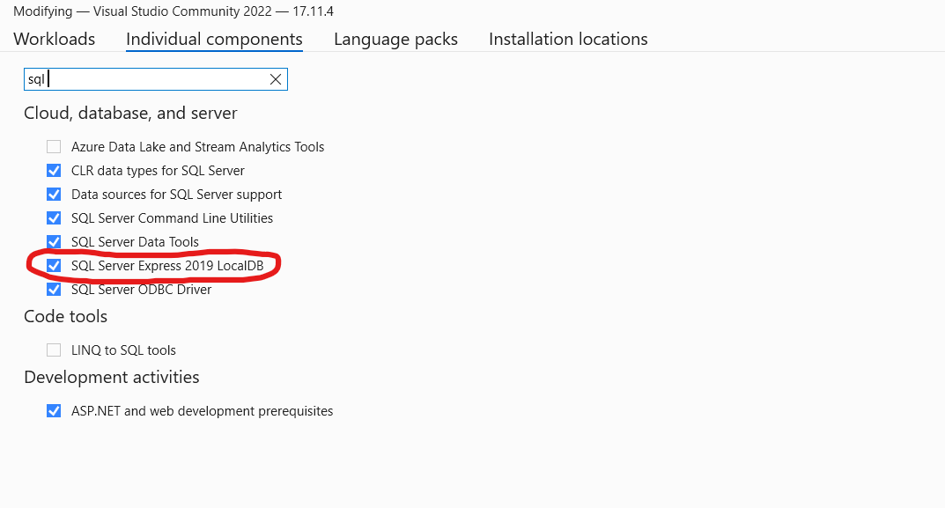
Fig. 2.1. Installing SQL Server LocalDB via VS Installer
The next step is to add Entity Framework Core to the project. Use a PowerShell command prompt to run the following command shown in the project folder (for SportsStore it is /SportsSln/SportsStore).

dotnet add package Microsoft.EntityFrameworkCore.Design
dotnet add package Microsoft.EntityFrameworkCore.SqlServer

These packages install Entity Framework Core and the support for using SQL Server. Entity Framework Core also requires a tools package, which includes the command-line tools required to prepare and create databases for ASP.NET Core applications. To install them, run the following command (the directory in which it is executed is not important):

dotnet tool install --global dotnet-ef

Configuration settings, such as database connection strings, are stored in JSON configuration files. To describe the connection to the database that will be used for the data, add the entries shown in listing below to the appsettings.json file in the project folder.

{
"Logging": {
"LogLevel": {
"Default": "Information",
"Microsoft.AspNetCore": "Warning"
}
},
"AllowedHosts": "*",
"ConnectionStrings": {
"SportsStoreConnection": "Server=(localdb)\\MSSQLLocalDB;Database=SportsStore;MultipleActiveResultSets=true"
}
}

Here we create a Connection string named "SportsStoreConnection". In its value, we specify a connection to a LocalDB database named SportsStore (Database=SportsStore;) and enable the multiple active result sets feature (MultipleActiveResultSets=true), which is required for some database queries that will be made by the SportsStore application using Entity Framework Core. Choose a database name that is relevant to the topic of your project and specify these names in your connection string.

Entity Framework Core provides access to the database through a context class. We will add a class file named StoreDbContext.cs to the Models folder. Choose a context class name that is relevant to the topic of your project. In this file, we will define the class shown in the listing below.

using Microsoft.EntityFrameworkCore;

namespace SportsStore.Models
{
public class StoreDbContext : DbContext
{
public StoreDbContext(DbContextOptions<StoreDbContext> options) : base(options) { }
public DbSet<Product> Products => Set<Product>();
}
}

The DbContext base class provides access to the Entity Framework Core’s underlying functionality, and the Products property will provide access to the Product objects in the database. The StoreDbContext class is derived from DbContext and adds the properties that will be used to read and write the application’s data. There is only one property for now, which will provide access to Product objects. Implement the context class according to your project's needs.

Entity Framework Core must be configured so that it knows the type of database to
which it will connect, which connection string describes that connection, and which
context class will present the data in the database. Listing below shows the required
changes to the Program.cs file:

using Microsoft.EntityFrameworkCore;
using SportsStore.Models;

var builder = WebApplication.CreateBuilder(args);

builder.Services.AddControllersWithViews();

builder.Services.AddDbContext<StoreDbContext>(opts => {
opts.UseSqlServer(builder.Configuration["ConnectionStrings:SportsStoreConnection"]);
});

var app = builder.Build();

app.UseStaticFiles();

app.MapDefaultControllerRoute();

app.Run();

The IConfiguration interface provides access to the ASP.NET Core configuration system, which includes the contents of the appsettings.json file. Access to the configuration data is through the builder.­Configuration property, which allows the database connection string to be obtained. Entity Framework Core is configured with the AddDbContext method, which registers the database context class and configures the relationship with the database. The UseSQLServer method declares that SQL Server is being used.

The next step is to create a repository interface and implementation class. The repository pattern is one of the most widely used, and it provides a consistent way to access the features presented by the database context class. To implement the repository for SportsStore, we will create a file named IStoreRepository.cs (choose an appropriate name for your project) in the Models folder and define the interface as follows:

namespace SportsStore.Models
{
public interface IStoreRepository
{
IQueryable<Product> Products { get; }
}
}

This interface uses IQueryable<T> to allow a caller to obtain a sequence of Product objects. The IQueryable<T> interface is derived from the more familiar IEnumerable<T> interface and represents a collection of objects that can be queried, such as those managed by a database. A class that depends on the IStoreRepository interface can obtain Product objects without needing to know the details of how they are stored or how the implementation class will deliver them.

To create an implementation of the repository interface, add a class file named
EFStoreRepository.cs in the Models folder and use it to define the class shown in
listing:

namespace SportsStore.Models
{
public class EFStoreRepository : IStoreRepository
{
private StoreDbContext context;
public EFStoreRepository(StoreDbContext ctx)
{
context = ctx;
}
public IQueryable<Product> Products => context.Products;
}
}

Аor the moment, the repository implementation just maps the Products property defined
by the IStoreRepository interface onto the Products property defined by the
StoreDbContext class. The Products property in the context class returns a DbSet<Product> object, which implements the IQueryable<T> interface and makes it easy to implement the repository interface when using Entity Framework Core.

ASP.NET Core supports services that allow objects to be accessed throughout the application. One benefit of services is they allow classes to use interfaces without needing to know which implementation class is being used. It means that application components can access objects that implement the IStoreRepository interface without knowing that it is the EFStoreRepository implementation class they are using. This makes it easy to change the implementation class the application uses without needing to make changes to the individual components.

Let's modify Program.cs to create a service for the IStoreRepository interface that uses EFStoreRepository as the implementation class.

using Microsoft.EntityFrameworkCore;
using SportsStore.Models;

var builder = WebApplication.CreateBuilder(args);

builder.Services.AddControllersWithViews();

builder.Services.AddDbContext<StoreDbContext>(opts => {
opts.UseSqlServer(builder.Configuration["ConnectionStrings:SportsStoreConnection"]);
});

builder.Services.AddScoped<IStoreRepository, EFStoreRepository>();

var app = builder.Build();

app.UseStaticFiles();

app.MapDefaultControllerRoute();

app.Run();

The AddScoped method creates a service where each HTTP request gets its own repository object, which is the way that Entity Framework Core is typically used.

Entity Framework Core can generate the schema for the database using the data model classes through a feature called migrations. When you prepare a migration, Entity Framework Core creates a C# class that contains the SQL commands required to prepare the database. If you need to modify your model classes, then you can create a new migration that contains the SQL commands required to reflect the changes. In this way, you don’t have to worry about manually writing and testing SQL commands and can just focus on the C# model classes in the application. Entity Framework Core commands are performed from the command line. Open a PowerShell command prompt and run the command shown in the listing below in the folder of your project to create the migration class that will prepare the database for its first use.

dotnet ef migrations add Initial

The result of successful execution is shown on the Figures 2.2-2.3.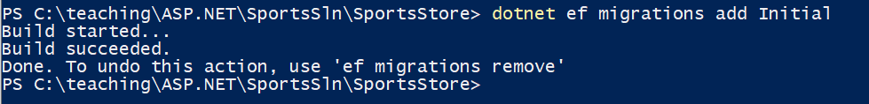
Fig. 2.2. Successful command execution
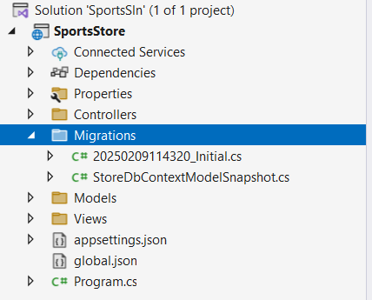
Fig. 2.3. Folder with initial migration

Populate your database with sample data using the instructions below.
Add a class file called SeedData.cs to the Models folder and define the class shown in listing depending on your entity:

using Microsoft.EntityFrameworkCore;
using static System.Net.Mime.MediaTypeNames;

namespace SportsStore.Models
{
public static class SeedData
{
public static void EnsurePopulated(IApplicationBuilder app)
{
StoreDbContext context = app.ApplicationServices
.CreateScope().ServiceProvider
.GetRequiredService<StoreDbContext>();

if (context.Database.GetPendingMigrations().Any())
{
context.Database.Migrate();
}

if (!context.Products.Any())
{
context.Products.AddRange(
new Product
{
Name = "Kayak",
Description = "A boat for one person",
Category = "Watersports",
Price = 275
},
new Product
{
Name = "Lifejacket",
Description = "Protective and fashionable",
Category = "Watersports",
Price = 48.95m
},
new Product
{
Name = "Soccer Ball",
Description = "FIFA-approved size and weight",
Category = "Soccer",
Price = 19.50m
},
new Product
{
Name = "Corner Flags",
Description = "Give your playing field a professional touch",
Category = "Soccer",
Price = 34.95m
},
new Product
{
Name = "Stadium",
Description = "Flat-packed 35,000-seat stadium",
Category = "Soccer",
Price = 79500
},
new Product
{
Name = "Thinking Cap",
Description = "Improve brain efficiency by 75%",
Category = "Chess",
Price = 16
},
new Product
{
Name = "Unsteady Chair",
Description = "Secretly give your opponent a disadvantage",
Category = "Chess",
Price = 29.95m
},
new Product
{
Name = "Human Chess Board",
Description = "A fun game for the family",
Category = "Chess",
Price = 75
},
new Product
{
Name = "Bling-Bling King",
Description = "Gold-plated, diamond-studded King",
Category = "Chess",
Price = 1200
});
context.SaveChanges();
}
}
}
}

The static EnsurePopulated method receives an IApplicationBuilder argument, which is the interface used in the Program.cs file to register middleware components to handle HTTP requests. IApplicationBuilder also provides access to the application’s services, including the Entity Framework Core database context service.
The EnsurePopulated method obtains a StoreDbContext object through the IApplicationBuilder interface and calls the Database.Migrate method if there are any pending migrations, which means that the database will be created and prepared so that it can store Product objects. Next, the number of Product objects in the database is checked. If there are no objects in the database, then the database is populated using a collection of Product objects using the AddRange method and then written to the database using the SaveChanges method.
The final change is to seed the database when the application starts, which I have done by adding a call to the EnsurePopulated method from the Program.cs file, as shown in listing:

using Microsoft.EntityFrameworkCore;
using SportsStore.Models;

var builder = WebApplication.CreateBuilder(args);

builder.Services.AddControllersWithViews();

builder.Services.AddDbContext<StoreDbContext>(opts => {
opts.UseSqlServer(builder.Configuration["ConnectionStrings:SportsStoreConnection"]);
});

builder.Services.AddScoped<IStoreRepository, EFStoreRepository>();

var app = builder.Build();

app.UseStaticFiles();

app.MapDefaultControllerRoute();

SeedData.EnsurePopulated(app);

app.Run();

If you need to reset the database, then run this command after changing --context option value to the name of you context class in the project folder:

dotnet ef database drop --force --context StoreDbContext

Start ASP.NET Core, and the database will be re-created and seeded with data.

Task 3. Displaying data on the web page
Modify the controller to display data from DB on the web-page.
For example project it looks like the following:

Content of HomeController.cs
using Microsoft.AspNetCore.Mvc;
using SportsStore.Models;

namespace SportsStore.Controllers
{
public class HomeController : Controller
{
private IStoreRepository repository;

public HomeController(IStoreRepository repo)
{
repository = repo;
}

public IActionResult Index() => View(repository.Products);
}
}

Content of Views/Home/Index.cshtml
@model IQueryable<Product>

@foreach (var p in Model ?? Enumerable.Empty<Product>())
{
<div>
<h3>@p.Name</h3>
@p.Description
<h4>@p.Price.ToString("c")</h4>
</div>
}
After running the project the home page looks like on the Fig. 3.1.
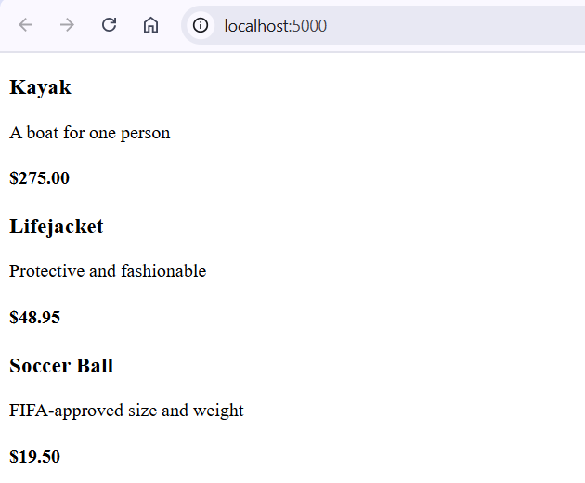
Fig. 3.1. Displaying DB data on the view

Task 4. Implement paging
- In the Models folder, create a ViewModels subfolder. A View Model is an entity created specifically for transferring data between the controller and the view, which is created during application operation and is not stored in the database.
- In the ViewModels folder, create a PagingInfo class to store paging data (number of records per page, total number of records, number of pages, etc.).
- In the ViewModels folder, create a View Model to display a list of entities on a page. It should include a collection of entities and information about paging.
- Add paging support to the controller. To do this, change the Index method so that it accepts the current page number and implement a query to the database to retrieve elements for this page. Pass the View Model instance created in step 3 to the view.
- Adapt the view to display a list of products from the View Model.
- Add an element to the page to select the current page.

Task 5. Styling
- Install the Bootstrap framework by running the following commands in the project folder:
dotnet tool install --global Microsoft.Web.LibraryManager.Cli

libman init -p cdnjs
libman install bootstrap -d wwwroot/lib/bootstrap
- Modify the base page template (_Layout.cshtml). Add elements for the header and footer.
- Style the entity list and paging element.

Push the project source code and laboratory assignment report to the corporate git repository.

Self-checkup questions.
- Describe the MVC pattern and its main components.
- How do you configure a database connection using EF Core?
- In which file are entities registered to be stored in the database tables?
- What is a Model and what is a View Model? What is the difference between them?
- How do you pass a query string argument to a controller's Action method?
- How do you define the model that the view will work with?

